**1. Use VLOOKUP to find the product names for each ProductID in the Orders**

**worksheet.**

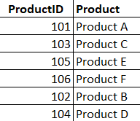

**2. Use VLOOKUP to find the price for each ProductID in the Orders worksheet, then**

**calculate the TotalPrice by multiplying the Quantity by the Product Price.**

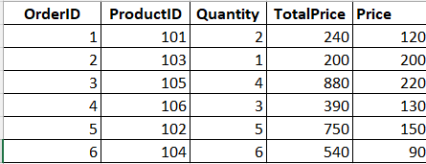

**3. Use VLOOKUP to check if there are any ProductIDs in the Orders worksheet that**

**do not exist in the Products worksheet.**

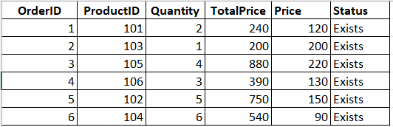

**4. Assume a discount of 10% is given on all products. Use VLOOKUP to find the**

**original price and then calculate the discounted price.**

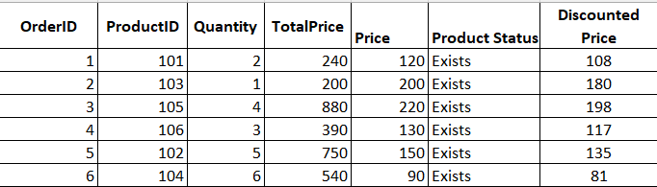

**5. Use VLOOKUP to find the price for each ProductID and then calculate the order**

**value. Find the maximum order value from the list.**

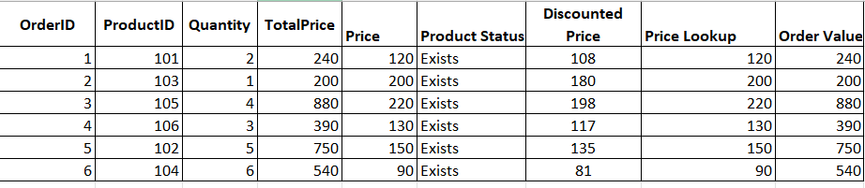

**6. Use VLOOKUP to find out which products from the Products worksheet have not**

**been ordered.**

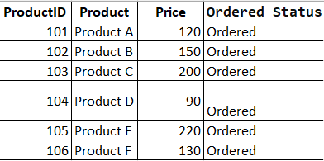

**7. Use VLOOKUP to find the Product name and summarize the total quantity sold**

**for each product.**

